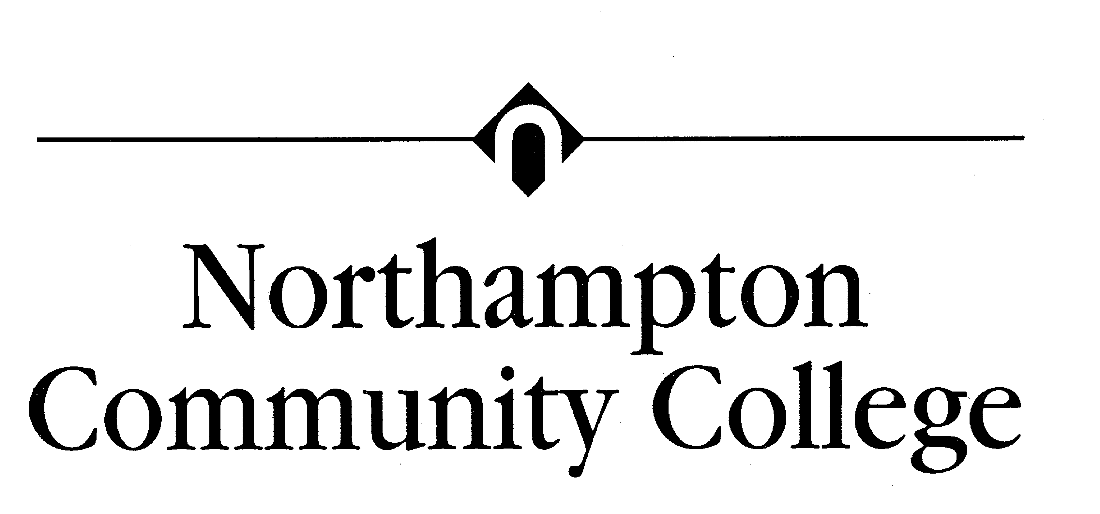
(610) 861-5500
www.northampton.edu
QUICK REFERENCE:
Academy Website: cisco.netacad.net
Study guides: kmanna.net then “NCC Cisco”
CNA Username:
CNA Password:
CNA ID#

Syllabus for Data Communications and LAN’s CISC 231 (CCNA-1)
(4 Credit Hour Course) MW 8:00 – 9:50 PM
Instructor: Kevin Manna, Founders 201
610-861-5392
Office Hours:
Monday & Wednesdays: 4:00-5:00 PM
Tuesday: 2:30-4:30 PM
Other Times by Appointment
E-mail kmanna@northampton.edu
Website: www.kmanna.net

Text: Networking Basics, CCNA 1 Companion Guide, 2006 Cisco Press, ISBN 1-58713-164-1 AND CCNA 1 Lab Companion, 2006 Cisco Press, ISBN 1-58713165x

The book store should carry the Lab pack which includes text and lab book under separate ISBN.

Catalog Description: Provides the foundation for work in data communications and local area network management; OSI Model and/or TCP/IP protocol stack model covered in detail; data transmission principles, media, major protocols, topologies, routing methods, introduction to networking principles, and Network operating system management fundamentals.

Outcomes:
At the completion of this course, students will be able to demonstrate the following competencies:
• Be able to identify and describe IP Address Classes.
• Proficient in using the binary number system.
• Proficient in IP address subnetting techniques.
• Proficient in the use of the three basic Boolean functions (AND, OR, NOR).
• Be able to describe the purpose of the OSI Model and the functions of each layer.
• Be able to describe the process of data encapsulation
• Be able to make a patch cable.
• Proficient in detailing the specifications of networking media (copper, fiber, wireless).
• Be able to describe and apply CAT 5 cabling standards.
• Be proficient in the use of a cable tester.
• Proficient in planning, designing, and installing work group and peer-to-peer LANs.
• Be able to describe the purpose of the TCP/IP Protocol Stack and the functions of each layer.
• Be able to identify which layer of the OSI Model specific TCP/IP protocols reside.
• Be able to compare and contrast the OSI Model and TCP/IP Protocol Stack.
• Proficient in detailing the specifications of Ethernet.
• Be able to identify and describe Ethernet families (10BaseT, Fast Ethernet).
• Be able to describe the function of MAC addresses.

This course is predominantly a lecture course, but it will contain some labs and group exercises. These exercises are designed to increase the student’s familiarity with the networking concepts discussed in the lectures and readings.

Class Labs will occur after the discussion of a topic. Additional lab time can be made available during the instructor’s office hours or via lab passes.

A Study Guide will be provided for each Chapter. It is the student’s responsibility to complete these. They are for YOUR benefit and will assist you when studying for the tests. Study Guides are due on the class day FOLLOWING its respective lecture. The CD accompanying your text is an invaluable tool.

Weather Hotline Number: 610-861-4595

CISC 231 Calendar |  | BASED on the REVISED Third Edition
Day | Month | Topic | Assignment
27 | August | CCNA site, Packet Tracer, Intro To Networking Ch 1 | Read Ch 1, LAB 1.1.x
29 | August | Intro To Networking, Network Math Ch 1 | Read Ch 2, LAB 1.2.x
3 | September | HOLIDAY
5 | September | Networking Fundamentals Ch 2: Terminology: Bandwidth, LAN, WAN, OSI | Read Ch 3
10 | September | Networking Fundamentals Ch 2: OSI, Devices, Topo Encapsulation
12 | September | Networking Media Ch 3: Layer 1: Media, Connections, and Collisions | Read Ch 4
17 | September | Meters Mini-Lab | LAB Demo
19 | September | Cable Testing Ch 4
24 | September | Labs: Cable Termination
26 | September | Chap 4 Labs continued | Read Ch 5
1 | October | Cabling LANs, Ch5 | Read Structured Cabling Handout
3 | October | Structured Cabling
8 | October | FALL BREAK (Monday night classes ARE held) | Read Ch 6
10 | October | Case Study - Structured Cabling
15 | October | Case Study - Structured Cabling | Read Ch 7
17 | October | Ethernet Fundamentals Ch 6
22 | October | Ethernet Technologies Ch 7
24 | October | Ethernet Switching, Ch 8 | Read Ch 8
29 | October | Ethernet Review | Read Ch 9
31 | October | TCP/IP and IP addressing, Ch 9
5 | November | IP exercises | Handout Worksheet
7 | November | Routing, Protocols, and Subnets, Chap 10 | Read Ch 10
12 | November | Lab: Subnetting
14 | November | Review of Subnetting | LAB 10.x
19 | November | TCP/IP Transport and Application Layers, Ch 11 | Read Ch 11
21 | November | HOLIDAY
26 | November | Session and Presentation layers
28 | November | Protocol Inspector Lab (if available) | Lab 11.x
3 | December | WAN's and Routers CCNA2, Ch1
5 | December | Case study discussion and notation
10 | December | Router Lab | LAB CCNA 2: 1.2.x
12 | December | Review
TBA FINAL EXAM

Grading will be assigned approximately per the following:

Assignments/Labs 20%
Tests (One on-line test after each chapter) 44%
Cabling Design Project/Case Study 15%
Final Exam(1) 21%

With the exception of Chapter 1 test and the final exam, all tests will be taken at home on YOUR time. They will be announced one class period ahead of time and will be active for at least 48 hours. Each chapter test contains approximately 20 questions. Tests may not normally be retaken. Tests can be made up only in the event of a medical emergency directly related to the student and verified by a written doctor’s excuse.

A one-time award of 5 points will be added to one of your exams if you stop by my office for an informal “how’s the semester going?” meeting after the third test and before Fall Break.

THE COLLEGE ATTENDANCE POLICY IS STRICLTY ADHERED TO. You can not learn if you are not present and participating. Please arrive on time. Two lates will be considered an absence.

