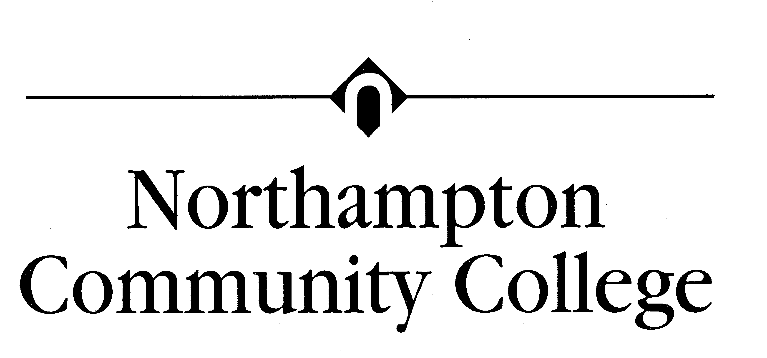
(610) 861-5500
www.northampton.edu
QUICK REFERENCE:
Academy Website: cisco.netacad.net
Study guides: kmanna.net
then “NCC Cisco”
CNA Username:
CNA Password:
CNA ID#

Syllabus for Data Communications and LAN’s CISC 231 (CCNA-1)
(4 Credit Hour Course) MW 8:00 – 9:50 PM
Instructor: Kevin Manna, Founders 201
610-861-5392
Office Hours:
Monday: 4:00-5:00 PM
Tuesday: 3:00-5:00 PM
Thursday: 3:00-4:00 PM
Other Times by Appointment
E-mail kmanna@northampton.edu
Website: www.kmanna.net

Text: Networking Basics, CCNA 1 Companion Guide, 2006 Cisco Press, ISBN 1-58713-164-1 AND CCNA 1 Lab Companion, 2006 Cisco Press, ISBN 1-58713165x. The book store should carry the Lab pack which includes text and lab book under separate ISBN: TBA

Catalog Description: Provides the foundation for work in data communications and local area network management; OSI Model and/or TCP/IP protocol stack model covered in detail; data transmission principles, media, major protocols, topologies, routing methods, introduction to networking principles, and Network operating system management fundamentals.

Outcomes:
At the completion of this course, students will be able to demonstrate the following competencies:
• Be able to identify and describe IP Address Classes.
• Proficient in using the binary number system.
• Proficient in IP address subnetting techniques.
• Proficient in the use of the three basic Boolean functions (AND, OR, NOR).
• Be able to describe the purpose of the OSI Model and the functions of each layer.
• Be able to describe the process of data encapsulation
• Be able to make a patch cable.
• Proficient in detailing the specifications of networking media (copper, fiber, wireless).
• Be able to describe and apply CAT 5 cabling standards.
• Be proficient in the use of a cable tester.
• Proficient in planning, designing, and installing work group and peer-to-peer LANs.
• Be able to describe the purpose of the TCP/IP Protocol Stack (DoD Model) and the functions of each layer.
• Be able to identify which layer of the OSI Model specific TCP/IP protocols reside.
• Be able to compare and contrast the OSI Model and TCP/IP Protocol Stack.
• Proficient in detailing the specifications of Ethernet.
• Be able to identify and describe Ethernet families (10BaseT, Fast Ethernet).
• Be able to describe the function of MAC addresses.

This course is predominantly a lecture course, but it will contain some labs and group exercises. These exercises are designed to increase the student’s familiarity with the networking concepts discussed in the lectures and readings.
CISC 231 Calendar
Day | Month | Topic | Assignment
16 | January | CCNA site, Computer AND Computing Basics Ch 1 | Read Ch 1, LAB 1.1.x
21 |  | No Class
23 |  | Computer AND Computing Basics, Binary math Ch 1 | Read Ch 2, LAB 1.2.x
28 |  | Networking Fundamentals Ch 2: Bandwidth, LAN, OSI | TEST Ch 1
30 |  | Networking Fundamentals Ch 2: OSI, Devices, Topo Encapsulation | Read Ch 3
4 | February | Networking Media Ch 3: Layer 1: Media, Connections, and Collisions | Read Ch 4
6 |  | Meters Mini-Lab | LAB Demo
11 |  | Lab continuation
13 |  | Cable Testing Ch 4
18 |  | Labs: Cable Termination | Read Ch 5
20 |  | Chap 4 Labs continued | Read Appendix A
25 |  | Cabling LANs, Ch5
27 |  | Structured Cabling, Appendix A | Read Ch 6
3 | March | Case Study - Structured Cabling
5 |  | Case Study - Structured Cabling | Read Ch 7
10 |  | Ethernet Fundamentals Ch 6 | Read Ch 8
12 |  | Ethernet Technologies Ch 7, Ethernet Switching, Ch 8
17 |  | SPRING BREAK
19 |  | SPRING BREAK | Read Ch 9
24 |  | Ethernet Review
26 |  | TCP/IP and IP addressing, Ch 9 | Handout Worksheet
31 |  | IP exercises | Read Ch 10
2 | April | Routing, Protocols, and Subnets, Chap 10
7 |  | Lab: Subnetting | LAB 10.x
9 |  | Review of Subnetting
14 |  | More Subnetting | Read Ch 11
16 |  | TCP/IP Transport and Application Layers, Ch 11
21 |  | Session and Presentation layers | Lab 11.x
23 |  | Protocol Inspector Lab (if available)
28 |  | WAN's and Routers CCNA2, Ch1
30 |  | Case study discussion and notation | LAB CCNA 2: 1.2.x
5 | May | Router Lab
7 |  | Review

<ALL LABS WILL BE completed DURING CLASS TIME>
Class Labs will occur after the discussion of a topic. Additional lab time can be made available during the instructor’s office hours or via lab passes. If you feel you need more time to complete a lab, it is your responsibility to ask for a lab pass to come in when no classes are in the room. Some labs may be completed at home using PacketTracer 4.1.

A Study Guide will be provided for each Chapter. It is the student’s responsibility to complete these. They are for YOUR benefit and will assist you when studying for the tests. Study Guides are due on the class day FOLLOWING the test for its respective module. THEY WILL NOT BE ACCEPTED IF LATE! Please email completed study guides to me. When sending include in the SUBJECT line, your last name, the course number (CISC231-01), and the Chapter or Module #. The CD accompanying your text is an invaluable tool and can be of great assistance in completing the study guides.

Grading will be assigned approximately per the following:

Assignments/Labs 20%
Tests (One on-line test after each chapter) 44%
Cabling Design Project/Case Study 15%
Final Exam(1) 21%

With the exception of Chapter 1 test and the final exam, all tests will be taken at home on YOUR time. They will be announced one class period ahead of time and will be active for at least 48 hours. Each chapter test contains approximately 20 questions. Tests may not normally be retaken. Tests can be made up only in the event of a medical emergency directly related to the student and verified by a written doctor’s excuse.

Learning is a mutual process. Students are encouraged to share related life experiences. Participation is encouraged. Please ask questions at any time when you need clarification on a topic.

A one-time award of 5 points will be added to one of your exams if you stop by my office for an informal “how’s the semester going?” meeting after the third test and before Spring Break.

THE COLLEGE ATTENDANCE POLICY IS STRICLTY ADHERED TO. You can not learn if you are not present and participating. Please arrive on time. Two lates will be considered an absence.

Cell phone disruptions will not be tolerated! PLEASE respect your fellow students and instructor by turning phones OFF!

Weather Hotline Number: 610-861-4595

