Name: _____________________________________ Date: ___________
CISC272 – CCNP-ROUTE
Chapter 2 – EIGRP

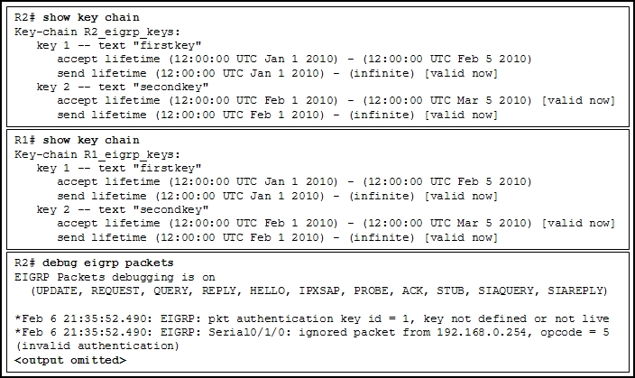
- Refer to the exhibit. A network administrator has configured R1 and R2 for EIGRP authentication with multiple keys and activation times. After functioning normally for a month, R1 and R2 are now no longer forming an EIGRP adjacency. How would you fix this?

- Explain how EIGRP would transition from Active to Passive

- Explain the EIGRP convergence process.

- Describe the EIGRP packet types.

- What solutions are used in an EIGRP network to reduce DUAL computations?

- What is the EIGRP algorithm? Explain its components and how it works.

- What does EIGRP rely upon for reliability (protocol)? Explain.

- What parameters must EIGRP neighbors agree upon in order to form adjacencies?

- What is the formula for the EIGRP metric?

- Identify the K values in the EIGRP metric.

- Explain the following:
  - Advertised Distance
  - Feasible Distance
  - Successor
  - Feasible Successor

- How would you configure EIGRP authentication keys with a set lifetime? (give the commands).

- How can you prevent EIGRP routes from being stuck-in-active (SIA)?

- Why would you modify interface metrics when using EIGRP? Explain.

