Name: _____________________________________ Date: ___________
CISC272 – CCNP-ROUTE
Chapter 4 – Manipulating Routing Updates

- What criteria must exist before route redistribution can occur?

- What is the default seed metric for an OSPF route that is redistributed into EIGRP?
- How can you prevent loops when using redistribution?

- 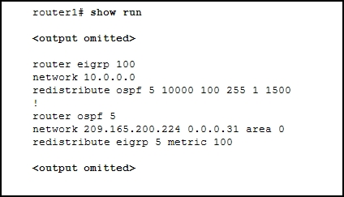
Given the above, why aren’t the EIGRP routes being advertised in the OSPF network?
- What does the “subnets” keyword do when configuring redistribution?
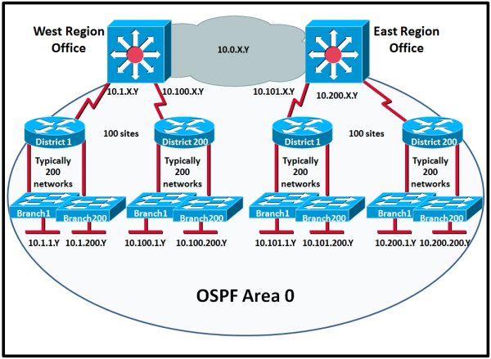
- Major problems with routing updates are occurring in the above network. What solution should be implemented to bring about efficiency?

- 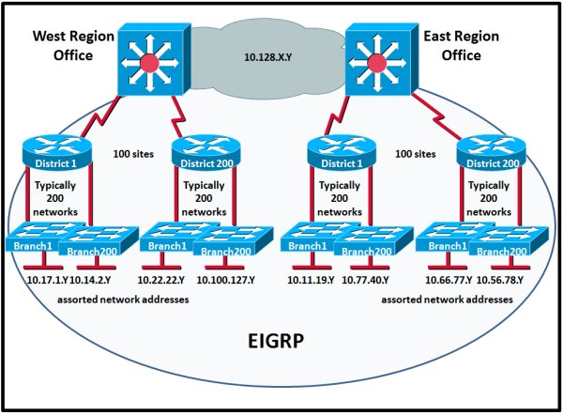
Major problems with routing updates are occurring in the above network. What solution should be implemented to bring about efficiency?
- What is a route tag in RIPv2?

- 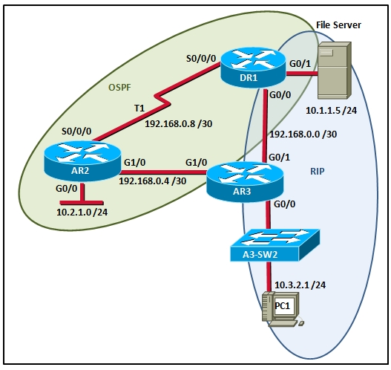
Given the default configurations and convergence, what path will packets from PC1 take to the file server?
- A router has learned the route 192.168.1.0 /24 from multiple sources. These sources are as follows:
- RIPv1 route with a metric of 12
- EIGRP with a metric of 25189
- OSPF E2 route with a metric of 125
- EIGRP external route with a metric of 3489
- OSPF type 1 route with a metric of 632
- OSPF route with a metric of 4
What route will be injected into the routing table?
- Explain the use of the prefix-list command.

- What is the final step when configuring ACLs or PBR?
- What is the neighbor command used for in OSPF and BGP?
- What is the purpose of a sequence number in a prefix-list?

