Name: _____________________________________ Date: ___________
CISC272 – CCNP-ROUTE
Chapter 5 – Path Control

- What is Path Control?

- What is an offset list? How are they applied with EIGRP?, RIP?

- Describe Cisco’s IP SLA functionality and features.

- What is Policy-Based Routing (PBR)?

- What PBR “set” commands can be used to override explicit routing table entries?

- Identify and describe the Path Control considerations in a redundant network topology. Be detailed here! (hint, hint)

- What path control consideration creates an effective use of bandwidth by having traffic use different paths for opposite directions?

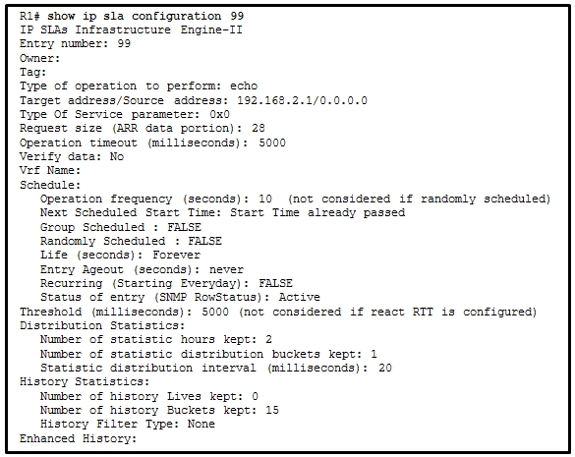
- Describe the details of the SLA configured on the router above.

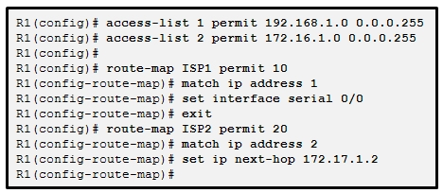
- Explain what the above PBR policy does.

- In the statement route-map DENY-ONE permit 30, what does the “30” stand for?

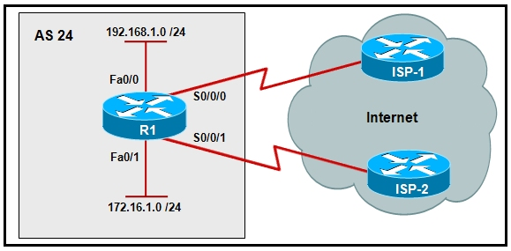
- Create a policy for the above network that forces 172.16.1.0 traffic to take the route to ISP-2 and the 192.168.1.0 traffic to take the path towards ISP-1.

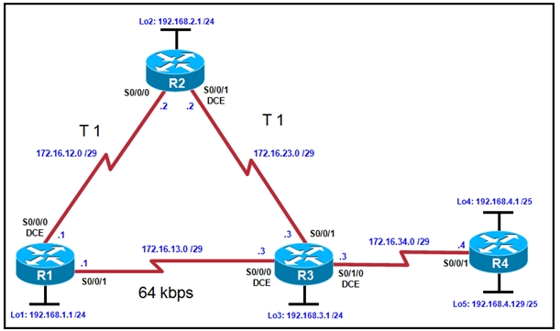
- Assuming RIP in the above example, create a policy or offset list to influence the path taken by traffic from 192.168.1.1 to 192.168.4.1 via the faster path of R2-R3-R4.

