**Name: _____________________________________ Date: ___________**

**CISC272 – CCNP-ROUTE**

**Chapter 7**

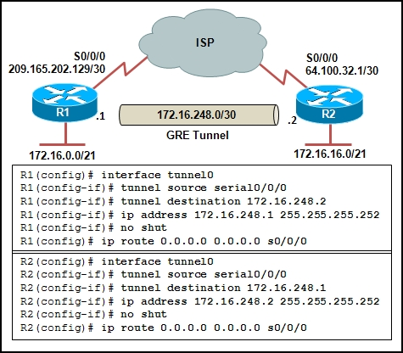

1. Refer to the exhibit. Pings to the ISP are successful but the tunnel does not work. What commands would fix the problem.
2. Assuming you fixed the above problem and IPsec is correct, what commands (think ACL) can be issued to encapsulate the GRE tunnel?
3. Which two UDP ports must be permitted inbound through the Internet-facing interface on a firewall to establish an IPsec tunnel and NAT-T?
4. What VPN solution is considered clientless for mobile workers?
5. Describe Context-Based Access Control (CBAC
6. Describe Zone-Based Firewall (ZBF)?
7. Branch office network design faces several challenges. Identify some of the specific issues.
8. What is the CIA triad?
9. What is AAA?
10. Which protocols are involved in the establishment of an IPsec VPN tunnel?
11. What are some limitations of IPsec by design? Be specific.
12. What items are specified by ISAKMP policy parameters?
13. Explain IPsec crypto maps? What are they? How are they used?
14. Describe the characteristics of broadband access?
15. Explain DSL.
16. Given the default routes below, which is the primary path?

ip route 0.0.0.0 0.0.0.0 172.16.20.2 70

ip route 0.0.0.0 0.0.0.0 192.68.6.1 80

ip route 0.0.0.0 0.0.0.0 202.16.20.2 60

ip route 0.0.0.0 0.0.0.0 212.68.6.1 90

1. How is NAT tuned to handle traffic that is sent through a VPN tunnel between a mobile worker and internal corporate resources?