NAME:_______________________________ DATE: ________

CCNP-ROUTE Study Guide

Chapter 8

1. 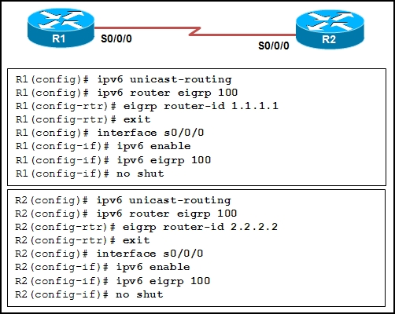

Refer to the exhibit. An administrator has configured routers R1 and R2 for EIGRP IPv6 as shown. After completing the configurations and verifying that the interfaces are up, the administrator notes that the routers have not formed an EIGRP adjacency. What needs to be done to allow the neighboring routers to establish adjacency?

1. Router# **show ipv6 route**

<output omitted>

C 2004::/96 [0/0]

via NVI0

What is indicated by the connected route entry above?

1. Write the following addresses in the shortest abbreviation allowed:
   1. 3FFE:1044:0000:0000:00AB:0000:0000:0057
   2. FE80:0404:0001:0000:0000:0000:ABDC:0123
2. Describe an “anycast” address. How would it be used in the network?
3. What is meant by solicited-node multicasts?
4. How does an IPv6 router respond to an ICMP router solicitation message? What address responds to the request?

1. What is stateless autoconfiguration in IPv6?
2. How do IPv6 enabled routers handle packet fragmentation?
3. What commands would properly configure NAT-PT on a router running IPv6 on S0/0 and IPv4 on FA0/0?

1. 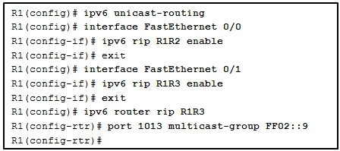  
   Refer to the exhibit. An administrator configured router R1 with two instances of RIPng. Based on the information in the exhibit, what must the administrator do next in order to exchange routes between both RIPng instances?
2. Identify the IPv6-specific extensions incorporated into MBGP?
3. Which two IPv4 to IPv6 transition techniques manage the interconnection of IPv6 domains?
4. What are the advantages of the NAT-PT technique for transitioning between IPv4 and IPv6?

1. 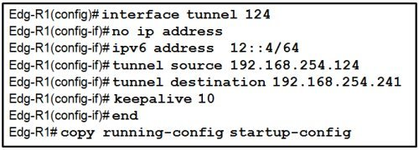  
   What is the purpose of this configuration?
2. Explain how a route-map can be used to redirect web traffic.
3. What IPv6 prefix is used for 6to4 automatic tunnels?
4. Explain the methods to route traffic through a 6to4 automatic tunnel?
5. 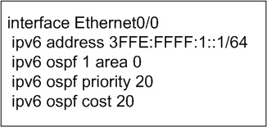  
   Explain the commands in the example above.

1. After the activation of IPv6 routing on a Cisco router and the configuration of IPv6 addresses on multiple interfaces, what is the remaining step to activate RIPng?

1. What is a recursive static route?